DS.140 Integration Design Specification



Scheme PO Integration

SCM_RICE_003

Author: Pranjul Garg

Creation Date: Jun 25, 2022

Last Updated: Jun 25, 2023

Version: 1.1

**Approvals:**

|  |  |
| --- | --- |
| <Approver 1> | <Rakesh Khanna / Naushad / Amit> |
| <Approver 2> | <Business Owner> |

# Document Control

## Change Record

| Date | Author | Version | Change Reference |
| --- | --- | --- | --- |
| 25-Jun-2022 | Pranjul Garg | 1.0 | No Previous Document |
| 25-Jun-2023 | Nidhi Siotia | 1.1 | Reviewed |
|  |  |  |  |
|  |  |  |  |

2

## Reviewers

| Name | Position |
| --- | --- |
| FHL Business | Business User |
| FHL IT Group | Fortis IT Team |
|  |  |
|  |  |

Contents

1 Document Control ii

1.1 Change Record ii

1.2 Reviewers ii

2 Introduction 4

2.1.1 Scope for this Document 4

2.1.2 Intended Audience 4

3 Overview 5

3.1 Business Objectives 5

3.2 Major Features 5

3.3 Glossary 5

4 High-Level Fusion Integration flow 6

5 Technical Design Details 7

5.1 OIC Services 7

5.2 Oracle PaaS DBCS components 7

5.3 Technical flow 7

6 Data FIELD Mapping 10

6.1 File format 10

6.2 Frequency 10

7 Exception handling 11

7.1 Scenarios 11

8 Assumptions / Considerations 12

9 Open and Closed Issues 13

9.1 Open Issues 13

9.2 Closed Issues 13

# Introduction

### Scope for this Document

This analysis specification document is prepared to layout the design for an integration to create scheme PO with zero price.

### Intended Audience

This document is intended for the following groups to provide the action items and consideration that are required to complete the implementation of the various Supply Chain and Finance related functionalities from Oracle Fusion.

#### Fortis Business Users

This document will be helpful for Fortis Business users to understand the technical design and process change with the new structure implemented in Oracle. The business user will validate this document after the verification of the requirement.

#### PwC Technical Team

The PwC technical team will use this document as a source technical design document to develop the technical solution to implement / deploy in Oracle Fusion.

#### Fortis IT Team

The Fortis IT Team must facilitate the PwC technical team for requisite details and other elements required from Business. The Fortis IT team is also responsible to arrange and provide required technical information wherever is required.

# Overview

Fortis Healthcare Limited (FHL) is a chain of hospitals, headquartered in India. Fortis started its health care operations from Mohali where first Fortis hospital was started. Later, the hospital chain purchased the healthcare branch of the Escorts group and increased its strength in various parts of the country. The Fortis health care also operates its hospital in Vasant Kunj, Faridabad, Gurgaon. The FMRI hospital at Gurgaon is the headquarter of Fortis healthcare with all the major facilities at the hospital.

This specification document is prepared to layout the design for an integration to create scheme PO with zero price.

## Business Objectives

The following are the business objectives.

1. To have a secure, reliable, and scalable design flow to validate and create scheme PO with zero price.
2. To have a solution providing the monitoring capabilities.

## Major Features

The proposed solution will have the following features involved:

1. OIC integration invokes PurchaseOrder Webservices to get the PO details.
2. The OIC integration then invokes a REST API to submit the scheme PO for approval.

## Glossary

REST

Representational State Transfer.

OIC

Oracle Integration Cloud

# High-Level Fusion Integration flow

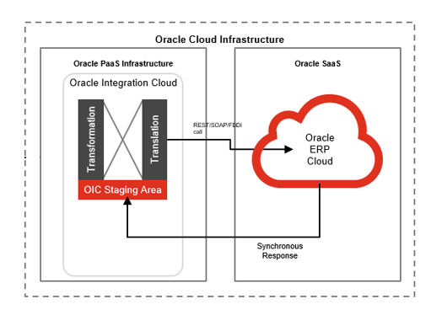

# Technical Design Details

This section describes the technical details of all the components involved in the design for an integration to create scheme PO with zero price.

## OIC Services

Following scheduled orchestration has been designed in OIC to build this integration:

|  |  |
| --- | --- |
| **OIC Integration Name** | Fortis Scheme PO Creation Integration |
| **OIC REST Endpoint URL** | [NA](https://oic-prod-nr5lr39yailj-bo.integration.ocp.oraclecloud.com:443/ic/api/integration/v1/flows/rest/FORT_TRIG_PO_LINE_AUTO_CANC_INTG/1.0/poLineCancel/) |
| **Method** | NA |

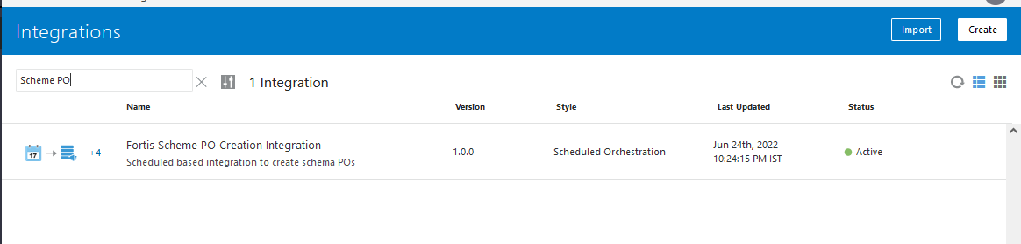

## Oracle PaaS DBCS components

This integration design does not use any DBCS related component.

## Technical flow

Following is the complete technical flow for this integration design:

1. User enters following scheme details on a given BPA line DFF or PO Line DFF (wherever any scheme is applicable):

* Fortis Scheme Number
* Scheme Valid from date
* Scheme valid to date
* Scheme / Free Quantity
* Scheme- Base Quantity
* Scheme Item

1. As per the requirement, a scheme PO with zero price should be created only if:

* Reference agreement is active and valid as per the agreement start date and end date.
* PO approval date is within the range specified by the scheme valid from date & scheme valid to date.
* A minimum of Scheme- Base Quantity (as specified in the BPA) is ordered on the PO.

1. The scheme PO is generated based on the following rules:

* Item on the scheme PO must be the Scheme Item on the BPA.
* Quantity of the scheme item on the scheme PO must be in multiple of Scheme / Free Quantity. The multiple factor will be determined by the Scheme- Base Quantity mentioned on the base PO.
* Price of the scheme item on the scheme PO must be overridden to 0.
* Total PO amount must be 0.
* The base PO number should be mentioned in the scheme PO header DFF field "Base PO Number"- Attribute 2 of PO Headers DFF.

1. Once the scheduled OIC integration runs, it invokes a custom ESS Job: Fortis_Scheme_PO_Details_Report which invokes a custom BIP report: /Custom/Interfaces/Integration Reports/Procurement/Fortis Scheme PO Details Report.xdo. This BIP report uses the following query to fetch the newly approved POs in the system (from the last successful run of this BIP report):

SELECT PO_HEADER_ID,

SEGMENT1 AS PO_NUMBER,

LAST_UPDATE_DATE,

APPROVED_DATE,

'SCHEME_PO' AS KEY

FROM PO_HEADERS_ALL pha

WHERE APPROVED_FLAG = 'Y'

AND TYPE_LOOKUP_CODE = 'STANDARD'

AND DOCUMENT_STATUS <> 'CLOSED'

AND NOT EXISTS

(SELECT 1

FROM po_headers_all pha1

WHERE pha.segment1 = pha1.attribute2)

AND (APPROVED_DATE BETWEEN NVL (

(SELECT MAX (H.PROCESSSTART)

FROM FUSION.ESS_REQUEST_HISTORY H

WHERE H.DEFINITION =

'JobDefinition://oracle/apps/ess/custom/purchasing/Fortis_Scheme_PO_Details_Report'

AND H.APPLICATION = 'FscmEss'

AND H.PROCESSSTART > SYSDATE - 2

AND H.EXECUTABLE_STATUS =

'SUCCEEDED'),

SYSDATE - 2)

AND SYSDATE)

1. Once OIC gets the report output, it checks every PO one by one to see if any of its line DFF has the scheme details populated. If not, then it checks if this is a BPA referenced PO. In case of BPA referenced PO, then OIC checks for the respective BPA line DFF as well to see if scheme details exist.
2. If scheme details do not exist at both the places, then OIC just bypasses this PO and checks for the next PO.
3. If OIC finds scheme details entered, then it fetches the scheme details from DFF (Item & Quantity). The price is set as 0 as default. All the remaining required info to create a scheme PO is taken as-is from the source base PO.
4. Once a scheme PO is created, it’s created in DRAFT status. OIC invokes a webservice to submit this for approval. As the scheme POs are set for auto-approval, the POs get auto-approved with 0 amount.
5. While creating scheme PO, the base PO number is mapped to ATTRIBUTE2 at PO_HEADERS_ALL.

**Server details:**

|  |  |  |  |  |
| --- | --- | --- | --- | --- |
| **Server** | **Host name** | **Port** | **Service Name** | **Username** |
| Oracle PaaS DB | 140.238.225.129 | 1521 | PRODPDB1.fhpubsn.fhvcn.oraclevcn.com | XXFH & XXFH_RO |



 

# Data FIELD Mapping

NA

## File format

NA

## Frequency

The integration is scheduled to run every 120 minutes.

# Exception handling

There can be various scenarios for an error to occur. This section defines those error scenarios, and the exception handling has been done to notify and act accordingly.

## Scenarios

In a tabular format give list of scenarios and exception handling

* If any of the step or node fails within the OIC integration, Global Fault section is configured within this OIC integration to send an OIC error notification with relevant details.
* The email id has been stored in OIC Lookup: Fortis_FaultNotification_EmailAddress_Lookup against the given OIC integration name.
* It also sends a notification with the details of the POs which have been processed in the given run. This notification also acts as a confirmation that the integration has been running fine.

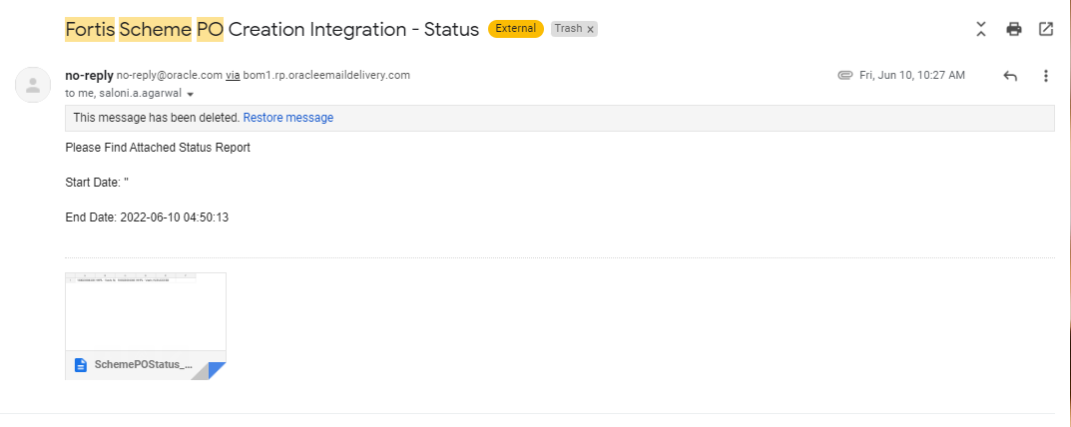

# Assumptions / Considerations

The Proposed Solution will have the following technical considerations.

In the future, if any product bug arises in functionality then this process needs to be revisited after the bug is fixed.

# Open and Closed Issues

## Open Issues

| ID | Issue | Resolution | Responsibility | Target Date | Impact Date |
| --- | --- | --- | --- | --- | --- |
|  |  |  |  |  |  |
|  |  |  |  |  |  |
|  |  |  |  |  |  |
|  |  |  |  |  |  |

## Closed Issues

| ID | Issue | Resolution | Responsibility | Target Date | Impact Date |
| --- | --- | --- | --- | --- | --- |
|  |  |  |  |  |  |
|  |  |  |  |  |  |
|  |  |  |  |  |  |
|  |  |  |  |  |  |